GENERAL PRESS RELEASE template
Warning after Yellow-legged hornet, (aka Asian Hornet) spotted in Runcorn
A destructive, and potentially dangerous, invasive insect has made its way to
the UK. [headers optional]
An awareness campaign is ongoing on a nationwide scale to help you
spot it and report it …and how to stay safe. [headers optional]

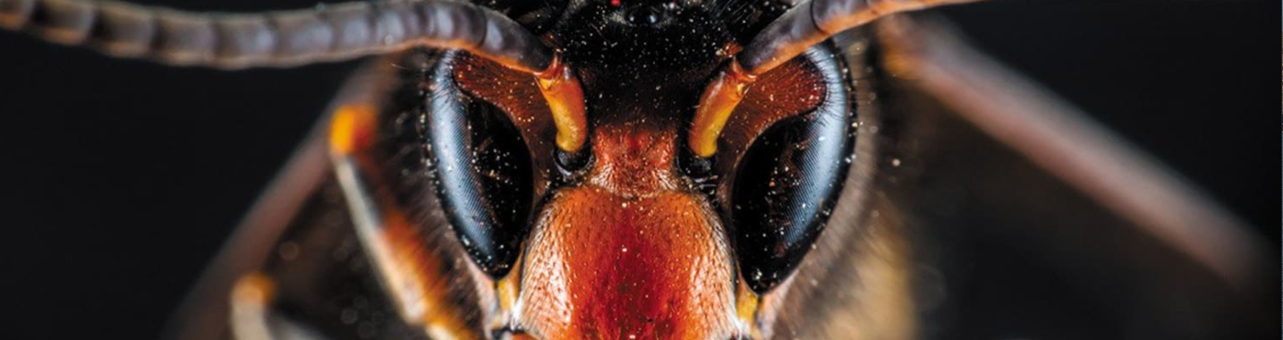
As the weather changes, the days shorten and the sun starts to dip following an exceptional summer, you’ll no doubt be expecting to see fewer flying insects around – and some of them you’ll probably be a bit wary of, because you know they can sting.
But are you keeping an eye out for the invasive Yellow-legged hornets? Or are those words new to you? If they are, now is the time to familiarise yourself with this invasive insect – it could make a huge difference to our native wildlife, and you might avoid a nasty run-in with them too.
The [insert branch title] Association is working tirelessly to make as many people as possible aware of the threat posed by the Yellow-legged hornet, and to encourage any sightings to be reported via an official app.
First discovered in the UK in 2016, the insect travelled to our shores from western Europe, where in France alone there are now over half a million nests annually. By 2022, just 16 Yellow-legged hornet nests had been discovered in the UK, however in as little as 3 years the dramatic 2025 rolling total is 118 nests! significantly more than in any previous year. Kent and other counties along the south coast took the brunt of the incursion, but there have been sightings in locations across the country, most recently in South Yorkshire and latterly Runcorn. Raising fears that they could become established here. The Animal and Plant Health Agency’s National Bee Unit is spearheading the control measures and has done a fantastic job of tracking, locating, and destroying nests.
So why the concern; what is it about the Yellow-legged hornet that has the scientists in such a dither? Put simply, the Yellow-legged hornet has the capacity to wreak havoc on our wildlife, through their predation on our native insect species and destruction of honey bee colonies. Just one nest of Yellow-legged hornets can consume up to 11kg of insects in a year. Anecdotal feedback from Jersey, where the Yellow-legged hornet is widespread, is that once prevalent populations of butterflies, bumble bees and honey bees and other beneficial insects have been significantly impacted.
We are aware of just how important pollinators are to our own health and wellbeing, and the security of our food chain. This could have huge consequences on our wider ecology, with many experts calling it the greatest threat to our native pollinators in a generation.

Concern is building, that an increase in the numbers of Yellow-legged hornets could pose a significant risk to public health too. While one hornet alone is unlikely to cause a problem, they can aggressively defend their nests. Whilst walking, an unintentional disturbance could have dangerous consequences. In the same way you wouldn’t mess with a wasps’ nest, it’s best to not get too close to a Yellow-legged hornet nests either.

So how do you know what to look for? Well, they can be identified by their very distinct markings: they’re slightly smaller than our native European hornet, which is two or three times the size of a common wasp, and are black with an orange face, a thin yellow band near the middle and a broader orange/yellow band around their abdomen, near the tail. The most distinguishing characteristic is their bright yellow legs, like they are wearing yellow socks – hence the name.

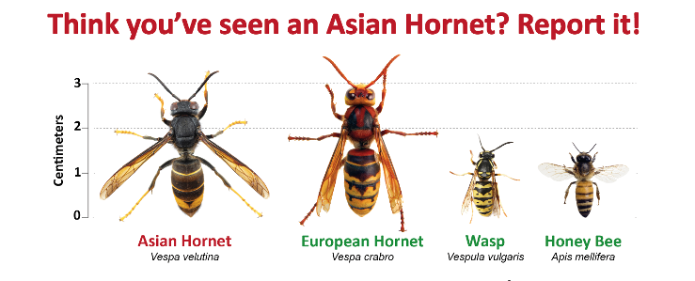
Any suspected sightings should be reported via the official Asian Hornet Watch app, along with a photo if possible. The app is available for both Android and iPhone devices. Experts from the Government’s National Bee Unit (NBU) will then be able to identify if there’s a nest nearby, and if so, destroy it. Anyone who thinks they’ve discovered a nest should stay at least 10 metres away to keep themselves safe.


If you would like to help support your local wildlife and help in the fight to eliminate the Yellow-legged hornet, please contact your local beekeeping association.

